# Jake Murray

Google Cybersecurity Certification

# File permissions in Linux

## Project description

For this project, I am a security professional at a fictional organization. My job is to update the permissions for a projects directory for the research team, as they do not currently reflect the correct levels of authorization. This is how I completed the project.

## Check file and directory details

I started by navigating to the /home/researcher2/projects directory and using the li command with -la options to list all of the child directories and files along with their permissions.

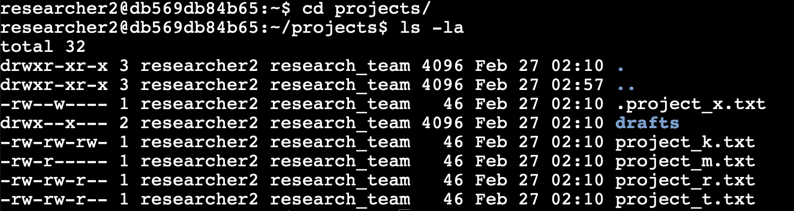

There is 1 drafts directory and 5 project files, one of which is hidden.

## Describe the permissions string

The permissions string is a 10 letter string broken up into 4 section.

The first letter (in this example d or -) indicate whether you are looking at a directory or file.

The next 9 characters are 3 sequences of the same 3 characters. Each sequence can have the letters rwx. Each character stands for a specific permission; r for read, w for write, and x for execute. If there is a dash instead of a letter, it means that that permission is not granted to that user or group.

The first sequence of these characters references the permissions of the user (researcher2), the second sequence references the permissions of the group (research_team) that the user belongs to, and the third sequence references users from other parts of the system outside of the user and group.

So, for example, if we look at the drafts directory:

The permissions string for this directory are drwx--x–--

d tells us that we are looking at a directory (folder) and not a file.

rwx is the first sequence of permissions, so it tells us that the user has read, write, and execute permissions.

--x is the second sequence and tells us that the group has only execute permissions.

–-- is the final sequence, telling us that users outside of researcher2 and research_team have no permissions at all to access this directory.

## Change file permissions

It was determined that none of the files should allow other users to write. So my first task was to use the chmod o-w project_k.txt command to remove the write permission for others from project_k.txt.

Here is the result:

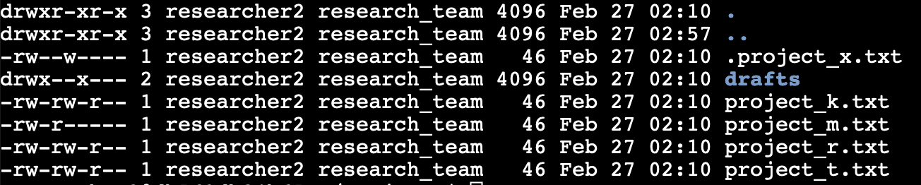

Next, the group should have no permissions for project_m.txt.

I used chmod g-r project_m.txt to complete this.

## Change file permissions on a hidden file

The file .project_x.txt is a hidden file that has been archived and should not be written to by anyone. (The user and group should still be able to read this file.)

I fixed this with the command chmod g-w,u-w,g+r .project_x.txt.

## Change directory permissions

Only the researcher2 user should be allowed to access the drafts directory and its contents. (This means that only researcher2 should have execute privileges.)

I used chmod g-x drafts to fix this permission.

## Summary

Here is the end result.

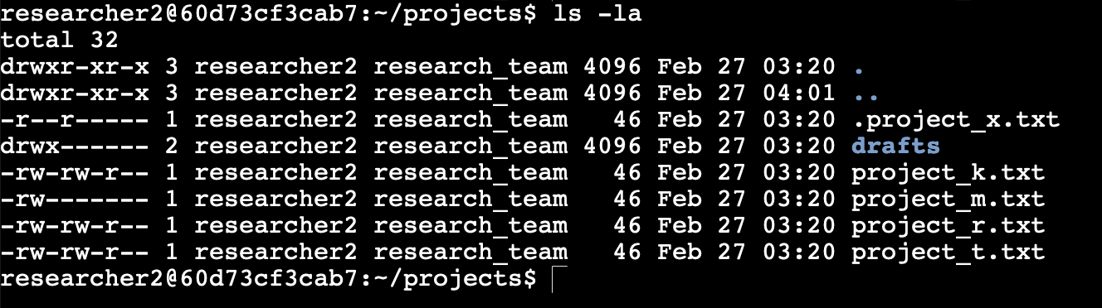

I used the chmod command several times according to authorizations that were provided to me. This fixed file and directory permissions, increasing security by allowing only those who needed specific permissions to read, write, and execute files and directories.